- Install and start Cisco IP communicator software.
*You will need administrative rights to successfully install and start the application for the first time.
2. Upon startup you will be prompted to “Tune” your computers audio, follow the onscreen prompts
3. You will be prompted with the following screen:
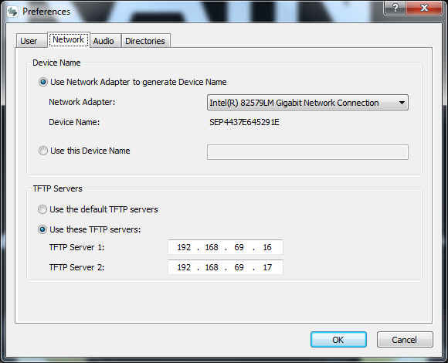
4. Fill in the TFTP servers as shown above.
5. Create a JIRA ticket in Telephony Queue, providing the “Device Name”.
Once your phone is configured by your administrator the softphone will contact the CallManager and download the information it needs for you to make calls.

